How to upload photos on Picasa :

- Log in to your existing Gmail email ID.

- On the top of the window, click on the ''More'' icon.

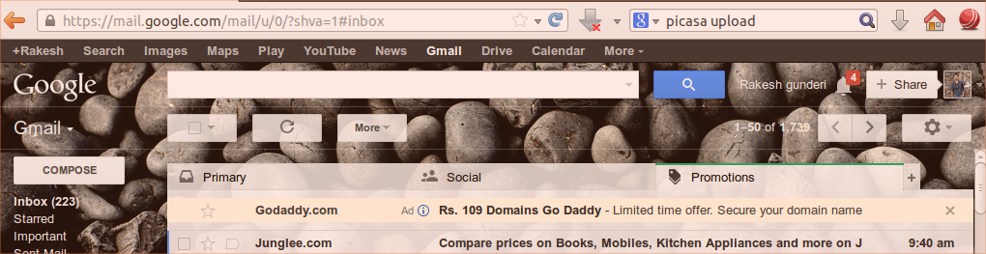

- Select the ''Photos'' option from the list that appears.

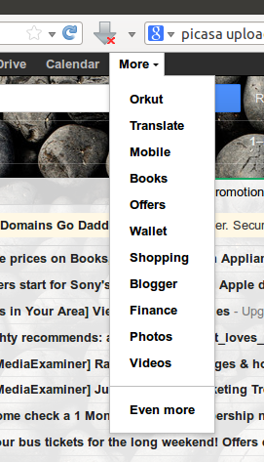

- For uploading and sharing photos with others, click on ''Upload photos''.

- Then browse to find the photo path which you want to upload or share.

- Select the desired photos (you can select multiple photos at a time), and click on “Open”.

- It will start to upload the selected photos to your account.

- Once uploading is complete, click on ''Add''.

- You can tag the people in the photos if you want or you can skip this step by clicking on “Skip”. or if you don't want just click ''Skip''.

- If you want to share the photos with others, type their email IDs and click ''Share''.

