Emails as a learning resource
These days many people manage their email on the web using services such as Gmail or Hotmail. These services offer access to email accounts through any web browser.
Another way to handle your email is to use an email client program like Thunderbird installed on your own computer. A program like this offers many advantages over using a web email client. It lets you organize your email exactly how you want, it enables you to check email when you are not connected to the Internet, and you can manage multiple email accounts in one place.

Checking Gmail on the web – can be a 'godown' experience
Learn Thunderbird – an email 'client' to make it a Library
Mozilla Thunderbird is a feature-rich, reliable, and secure tool for managing your email. It's free and open source software.

Before going to thunderbird you should follow below two steps in gmail.
1. FIRST STEP:-
Sign in to Gmail.
- Click the gear in the top right .
- Select Settings.
- Click Forwarding and POP/IMAP.
- Select Enable POP for all mail or Enable POP for mail that arrives from now on.
- Choose what to do with your messages after your POP client or device receives them.
- Click Save Changes, as shown in the below link.
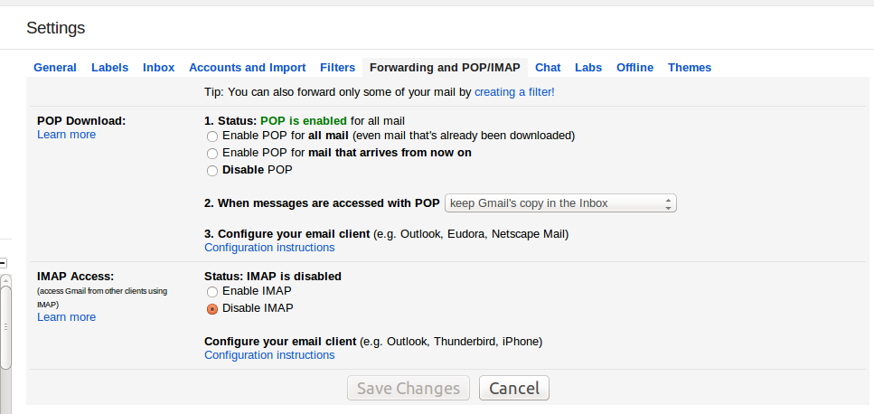

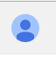
2. SECOND STEP:-
- Click the gear in the top right
- Click on Account and then scroll down to signing in and select Access for less secure apps .
- Turn on as showing below.
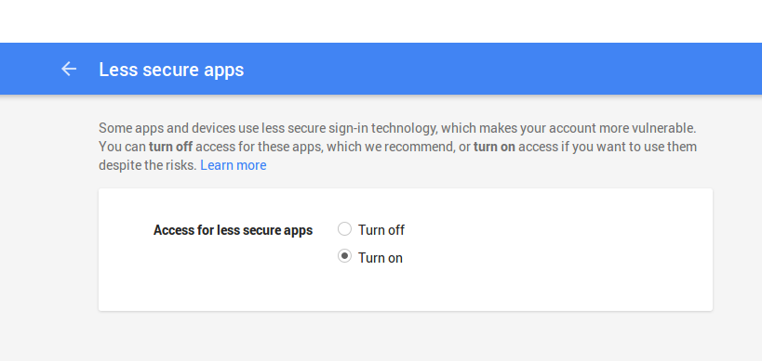

Then Logout from your gmail account.

Now, its time to configure Thunderbird.

Open Thunderbird by clicking: -
Applications – Internet – Thunderbird
Here's how to work your way through the automated setup process:

- Make sure that your computer is connected to the Internet and then start Thunderbird.
- On the first setup screen, enter your name, your email address, your password. Your password is your current email password. If you want Thunderbird to remember your password (so you don't need to keep typing it every time you check your mail), click the Remember password checkbox.
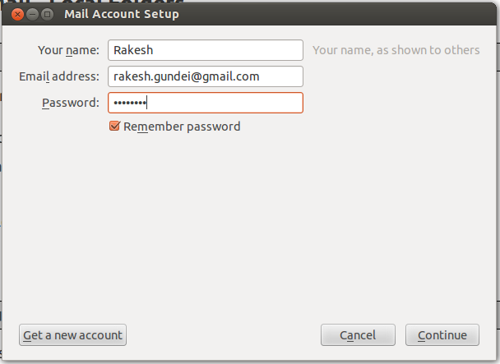

- Click the Continue button to go to the next step.
- Thunderbird tries to get your account settings by connecting to the database of Internet Service Providers (ISPs) that is maintained by Mozilla.
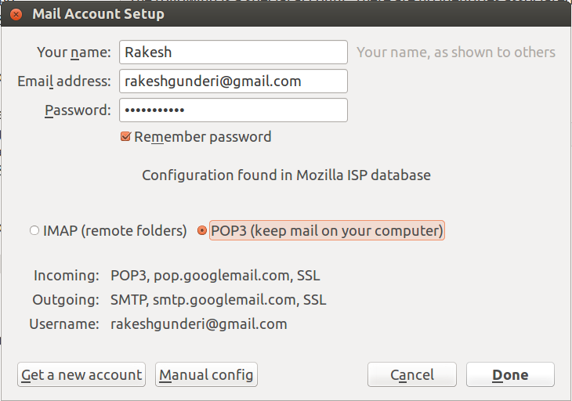

If Thunderbird finds the information for your email provider it automatically enters that information for you. Click the Create Account button to add the account. Click the Cancel button to stop the set up process.

- Once your account is created, Thunderbird asks you if you want it to be the default application for email, newsgroups, or feeds. Make your choices by clicking the checkboxes.

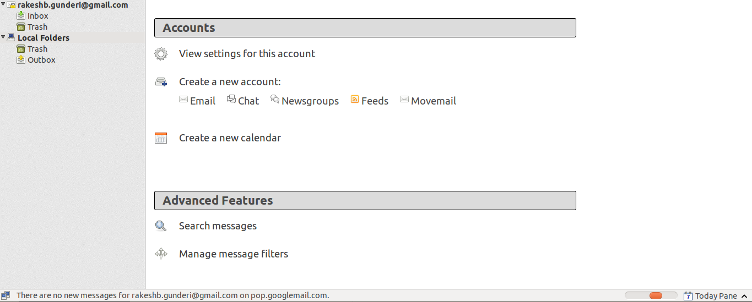

Your account has been created and you're ready to go!
Repeat this process for as many accounts as you want to add to Thunderbird.

For more details on configure :- https://support.google.com/mail/troubleshooter/1668960?hl=en&rd=1

