Addition using the number line

In class you have learnt that you can add numbers by counting forward. If we want to add 5 to 2, start from 2 and take 5 jumps forward.
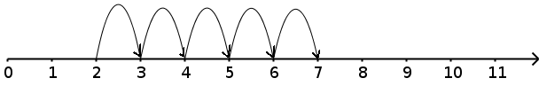
This can be written as
2 + 5 = 7

Use the given number line to add.
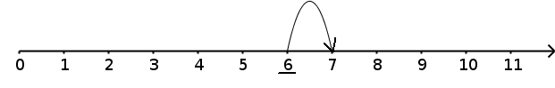
6 + 1 = _____
3 + 2 =____
5 + 4 = ____
4 + 2 = ___

8 + 3 = ___

Bunny is jumping along the number line. Write additions for the jumps.
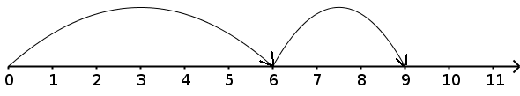
6 + 3 = 9

    

