Subtraction using number line

Look at the following example.

Subtract 3 from 8. Start from 8 and take 3 jumps backward.
Start
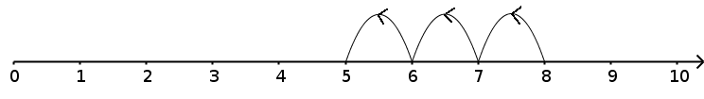
You reach 5. so, 8 – 3 = 5.

Use the given number line to subtract.
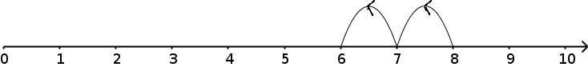
8 – 2 = 6

7 – 5= ___

4 – 2 =__

8 – 1 =___

9 – 6 =__

Fill in the boxes.

1. George has 8 marbles. 2. 9 birds are sitting on a tree
He gives away 3 marbles. Branch. 3 of them fly away.
Now he has ___ marbles. ___ of them are still on the
branch.

